**1. MAC Studio Fix Powder Plus Foundation**

[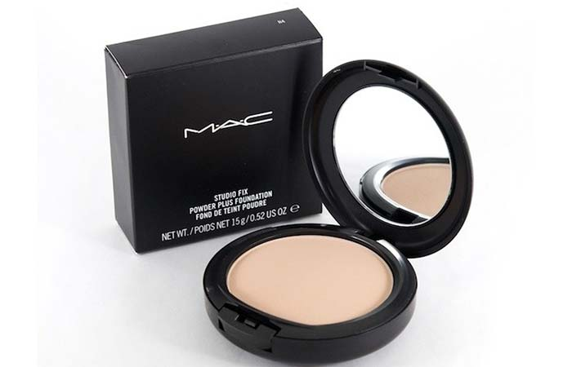](http://www.stylecraze.com/articles/best-mac-foundations/)

[**Save**](https://www.pinterest.com/pin/create/button/?guid=hvQeKU2xMzfb-4&url=http%3A%2F%2Fwww.stylecraze.com%2Farticles%2Fbest-mac-foundations%2F&media=http%3A%2F%2Fwww.stylecraze.com%2Fwp-content%2Fuploads%2F2014%2F05%2F1.-MAC-Studio-Fix-Powder-Plus-Foundation.jpg&description=11%20Best%20MAC%20Foundations%20For%20Different%20Skin%20Types)

This powder plus foundation is a one-step tool that gives you a smooth, all-matte and flawless, full-coverage finish. It’s long-wearing and allows your skin to breathe due to its lightweight, velvety texture.This compact comes in over 40 different shades for every skin tone.

***Pros***

* Easy application
* Buildable coverage
* Gives the no-makeup look
* Matte finish
* Color true and long-wearing
* It lasts you a good 7-8 months (depending on usage)

***Cons***

* Besides being a little pricey, there’s nothing else to it. However, it’s worth every penny.

[**Back To TOC**](http://www.stylecraze.com/articles/best-mac-foundations/#BackToToc)

**2. MAC Pro Longwear Foundation**

[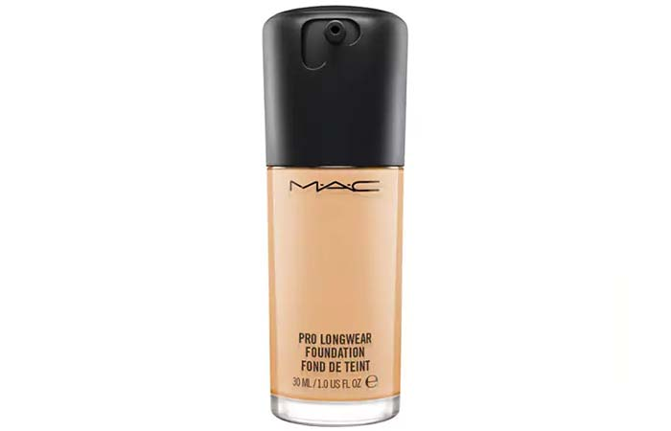](http://www.stylecraze.com/articles/best-mac-foundations/)

[**Save**](https://www.pinterest.com/pin/create/button/?guid=hvQeKU2xMzfb-5&url=http%3A%2F%2Fwww.stylecraze.com%2Farticles%2Fbest-mac-foundations%2F&media=http%3A%2F%2Fwww.stylecraze.com%2Fwp-content%2Fuploads%2F2014%2F05%2F2.-MAC-Pro-Longwear-Foundation.jpg&description=11%20Best%20MAC%20Foundations%20For%20Different%20Skin%20Types)

MAC claims that this Pro Long-wear foundation gives you up to 15 hours of wear in any environmental condition. It’s comfortable and long-wearing and allows your skin to breathe all day while it controls oil. It also consists of specially treated micronized pigments to help you achieve an even flawless, smoother and a natural matte finish.There are over 16 shades to choose from.

***Pros***

* Long-wearing
* Controls oil
* Photo-friendly
* Transfer-resistant
* Suitable for all skin types
* Humidity and sweat-resistant

***Cons***

* You have to work pretty fast with this foundation as it dries rather quickly

**MAC Pro Longwear Foundation Review**

The MAC Pro Longwear foundation is indeed long-wearing as per its claims. It looked just as fresh even after a long 12-hour day. It gives your skin a beautiful, natural finish. The coverage is buildable, and it’s great for regular use as it’s quite lightweight and does not clog pores. Coming to the texture, this liquid foundation is just the right amount of creamy. It does not transfer and stays on all day long. If you have acne prone skin and need to cover blemishes, this does a brilliant job.

**Rating:**5/5

**Price:**$35*

**Where to Buy MAC Pro Longwear Foundation Online?**

**Purchase Link:**[www.amazon.com](https://www.amazon.com/Pro-Longwear-Foundation-NW22-Mac/dp/B01N3TM7D8/ref=sr_1_4_s_it)

[**Back To TOC**](http://www.stylecraze.com/articles/best-mac-foundations/#BackToToc)

**3. MAC Studio Fix Fluid SPF 15 Foundation**

[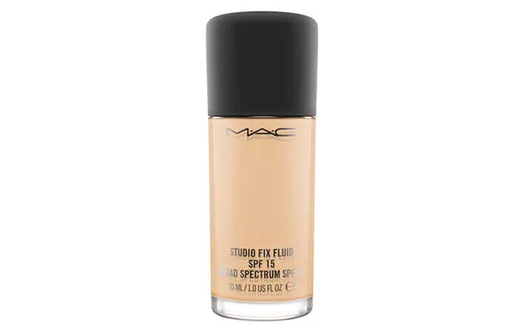](http://www.stylecraze.com/articles/best-mac-foundations/)

[**Save**](https://www.pinterest.com/pin/create/button/?guid=hvQeKU2xMzfb-6&url=http%3A%2F%2Fwww.stylecraze.com%2Farticles%2Fbest-mac-foundations%2F&media=http%3A%2F%2Fwww.stylecraze.com%2Fwp-content%2Fuploads%2F2014%2F05%2F3.-MAC-Studio-Fix-Fluid-SPF-15-Foundation.jpg&description=11%20Best%20MAC%20Foundations%20For%20Different%20Skin%20Types)

This foundation is an oil-controlling formula, and it offers a matte-finish with medium to full coverage. It also comes with broad spectrum UVA/UVB SPF 15/PA++ protection and helps you minimize the appearance of pores and imperfection giving you a smoother, more flawless finish.Available in over 30+ shades.

***Pros***

* Long-wearing, up to 24 hours
* Non-drying
* Non-caking
* Waterproof formula
* Photo-friendly
* Minimizes the appearance of imperfections
* Provides stay-true color
* Suitable for all skin types

***Cons***

* Packaging (no dispenser, pump or nozzle)
* It’s a little heavy or rather fancy for regular use

**MAC Studio Fix Fluid SPF 15 Foundation Review**

Although this foundation works for all skin types, it works exceptionally well for oily and combination skin types giving you a superb matte finish which looks so natural. The coverage ranges between medium to full and is buildable. It also contains sun protection and an SPF of 15. It just glides onto your skin and blends in beautifully. It’s also sweat and humidity resistant. One of the finest foundations by MAC!

**Rating:**5/5

**Price:**$29*

**Where to Buy MAC Studio Fix Fluid SPF 15 Foundation Online?**

**Purchase Link:**[amazon.com](https://www.amazon.com/MAC-Studio-Fluid-Foundation-NC30/dp/B001JBB184/ref=sr_1_2_s_it)

[**Back To TOC**](http://www.stylecraze.com/articles/best-mac-foundations/#BackToToc)

**4. MAC Mineralize Moisture SPF 15 Foundation**

[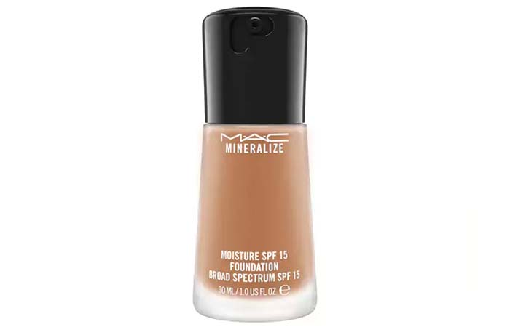](http://www.stylecraze.com/articles/best-mac-foundations/)

[**Save**](https://www.pinterest.com/pin/create/button/?guid=hvQeKU2xMzfb-7&url=http%3A%2F%2Fwww.stylecraze.com%2Farticles%2Fbest-mac-foundations%2F&media=http%3A%2F%2Fwww.stylecraze.com%2Fwp-content%2Fuploads%2F2014%2F05%2F4.-MAC-Mineralize-Moisture-SPF-15-Foundation.jpg&description=11%20Best%20MAC%20Foundations%20For%20Different%20Skin%20Types)

This mineralize foundation is designed to give you a satin finish which makes your skin appear refined, refreshed and lit from within. It comes in a combination of powders in cream-gel emulsion formula that creates an optical blurring effect – virtually diminishing imperfections and fine lines for an even tone. It also features MAC’s 77 mineral complex, vitamin E and shea butter. It’s available in 18 shades.

***Pros***

* Long-wearing
* Instantly hydrates your skin
* Provides instant radiance
* Offers broad spectrum UVA/ UVB SPF 15
* It’s suitable for all skin types including sensitive skin
* Blurs lines and the appearance of wrinkles

***Cons***

* The coverage is sheer to medium
* Pricey

**MAC Mineralize Moisture SPF 15 Foundation Review**

If you have really dry or sensitive skin – this is your holy grail! This is one of those foundations that can be worn on a daily basis especially because it’s lightweight and the finish is nice and dewy. It also lasts all day long, and you look perfectly put together without it smearing or oxidizing. It’s also one of the best foundations for women who are over 40 as it covers fine lines and wrinkles so effectively.

**Rating:**4.5/5

**Price:**$38*

**Where to Buy MAC Mineralize Moisture SPF 15 Foundation Online?**

**Purchase Link:**[amazon.com](https://www.amazon.com/Mineralize-Moisture-Foundation-Spectrum-NC30/dp/B00CBQF1FA/ref=sr_1_3_s_it?s=beauty&ie=UTF8&qid=1504002418&sr=1-3&keywords=MAC+Mineralize+Moisture+SPF+15+Foundation)

[**Back To TOC**](http://www.stylecraze.com/articles/best-mac-foundations/#BackToToc)

**5. MAC Next To Nothing Face Color Foundation**

[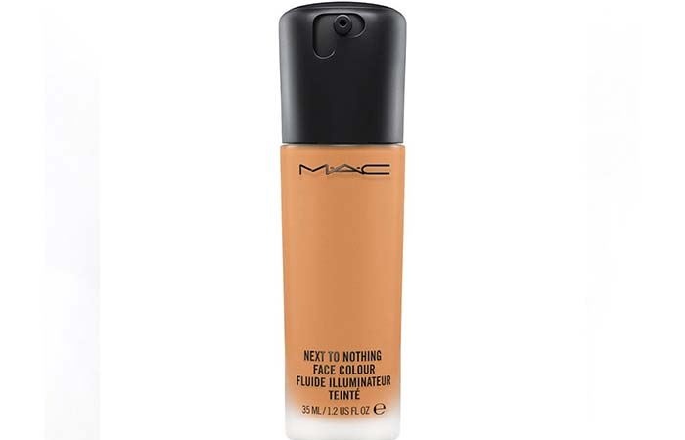](http://www.stylecraze.com/articles/best-mac-foundations/)

[**Save**](https://www.pinterest.com/pin/create/button/?guid=hvQeKU2xMzfb-8&url=http%3A%2F%2Fwww.stylecraze.com%2Farticles%2Fbest-mac-foundations%2F&media=http%3A%2F%2Fwww.stylecraze.com%2Fwp-content%2Fuploads%2F2014%2F05%2F5.-MAC-Next-To-Nothing-Face-Color-Foundation.jpg&description=11%20Best%20MAC%20Foundations%20For%20Different%20Skin%20Types)

This ultra balmy fluid is infused with nourishing ingredients and opalescent microspheres for a youthful glow that appears lit from within. This can be used by itself or under/over foundation. It brings out skin’s luminosity for sheer, balmy perfection. It has a shade range of around 8 colors.

***Pros***

* Lightweight
* Great for everyday use
* Provides hydration
* Refines skin texture
* Provides instant radiance
* Oil-free and suitable for all skin types
* Nourishes skin

***Cons***

* The coverage is between a sheer to medium

**MAC Next To Nothing Face Color Foundation Review**

If you are just starting out with foundation and want a simple sheer formula, then go for this one as it’s a brilliant product. It does what it claims. It lasts all day long even without a primer on. It does a good job at blurring out pores and evening out your skin tone. It makes your skin look healthy and radiant with a nice soft effect. For best results, you can[apply this foundation](http://www.stylecraze.com/articles/how-to-apply-foundation-on-face/?ref=content) with a damp sponge (beauty blender), and it will give you that perfect dewy glow. Also, it works for all skin types! But we felt it’s a little expensive for what it does and the coverage it provides – it isn’t anything exceptional for $31.

**Rating:**4/5

**Price:**$31*

**Where to Buy MAC Next To Nothing Face Color Foundation Online?**

**Purchase Link:**[maccosmetics.com](http://www.maccosmetics.com/product/13847/47402/products/makeup/face/foundation/next-to-nothing-face-colour#/shade/Dark_Plus)

[**Back To TOC**](http://www.stylecraze.com/articles/best-mac-foundations/#BackToToc)

**6. MAC Studio Waterweight SPF 30 Foundation**

[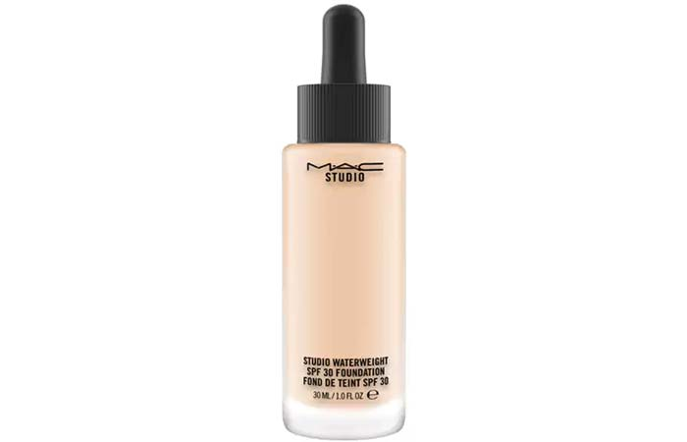](http://www.stylecraze.com/articles/best-mac-foundations/)

[**Save**](https://www.pinterest.com/pin/create/button/?guid=hvQeKU2xMzfb-9&url=http%3A%2F%2Fwww.stylecraze.com%2Farticles%2Fbest-mac-foundations%2F&media=http%3A%2F%2Fwww.stylecraze.com%2Fwp-content%2Fuploads%2F2014%2F05%2F6.-MAC-Studio-Waterweight-SPF-30-Foundation.jpg&description=11%20Best%20MAC%20Foundations%20For%20Different%20Skin%20Types)

This foundation delivers color in an ultra-fluid, thin, elastic gel-serum formula. The hydrating formula contains a moisture-fusion complex and it protects your skin with an SPF 30. It offers all-day wear and sheer to medium coverage. Available in an array of 23 shades.

***Pros***

* Long-wearing
* Controls oil
* Offers SPF 30
* Instantly hydrates
* Non-streaking and non-caking
* Super lightweight
* Suitable for all skin types

***Cons***

* Variable results
* Tricky to apply
* Sheer coverage

**MAC Studio Waterweight SPF 30 Foundation Review**

If you were on the lookout for an alternative to the heavier coverage foundations – this serum foundation is for you. It is extremely lightweight while it provides broad spectrum sun protection. It also contains beneficial antioxidants and reparative ingredients. It comes in a glass bottle with a dropper applicator, and you only need a tiny amount to cover your entire face. It blends in beautifully with a sponge giving you a satin finish that is neither matte nor moisturizing – just somewhere in the middle.

**Rating:**4.4/5

**Price:**$35*

**Where to Buy MAC Studio Waterweight SPF 30 Foundation Online?**

**Purchase Link:**[amazon.com](https://www.amazon.com/MAC-Studio-Waterweight-Foundation-NC20/dp/B016QWNCDC/ref=sr_1_1_s_it?s=beauty&ie=UTF8&qid=1504002583&sr=1-1&keywords=+MAC+Studio+Waterweight+SPF+30+Foundation)

[**Back To TOC**](http://www.stylecraze.com/articles/best-mac-foundations/#BackToToc)

**7. MAC Studio Tech Foundation**

[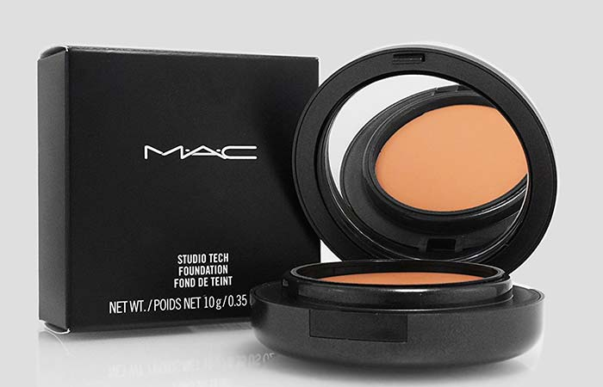](http://www.stylecraze.com/articles/best-mac-foundations/)

[**Save**](https://www.pinterest.com/pin/create/button/?guid=hvQeKU2xMzfb-10&url=http%3A%2F%2Fwww.stylecraze.com%2Farticles%2Fbest-mac-foundations%2F&media=http%3A%2F%2Fwww.stylecraze.com%2Fwp-content%2Fuploads%2F2014%2F05%2F7.-MAC-Studio-Tech-Foundation.jpg&description=11%20Best%20MAC%20Foundations%20For%20Different%20Skin%20Types)

The Studio Tech is a tri-system blend of water, emollients, and water that glides on as a soft, creamy emulsion. This innovative formula provides a full range of coverage and gives you that natural powder-perfect finish. It also helps to soften lines and create a flawless texture for every skin type. Over 27 different shades available.

***Pros***

* Long-wearing
* Full coverage
* Great for sensitive skin
* Refines skin and evens out skin tone
* Blends beautifully

***Cons***

* No SPF or sun protection
* It looks cakey if not blended properly

**MAC Studio Tech Foundation Review**

The MAC Studio Tech foundation comes in a compact package, and its consistency is thick and creamy. It’s one of the best foundations to hide scars. It’s best to use a buffing brush to apply this rather than using the sponge that comes along with the product for best results. It’s also ideal for sensitive skin. You can choose to top it up with some compact powder, and it stays put all day long.

**Rating:**4.3/5

**Price:**$35*

**Where to Buy MAC Studio Tech Foundation Online?**

**Purchase Link:**[amazon.com](https://www.amazon.com/MAC-Studio-Tech-NC42/dp/B000A6OTEM/ref=sr_1_7_s_it?s=beauty&ie=UTF8&qid=1504006468&sr=1-7&keywords=MAC+Studio+Tech+Foundation)

[**Back To TOC**](http://www.stylecraze.com/articles/best-mac-foundations/#BackToToc)

**8. MAC Studio Sculpt SPF 15 Foundation**

[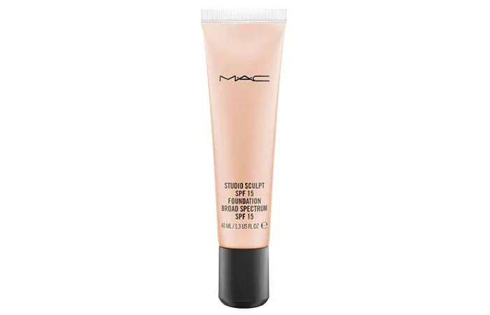](http://www.stylecraze.com/articles/best-mac-foundations/)

[**Save**](https://www.pinterest.com/pin/create/button/?guid=hvQeKU2xMzfb-11&url=http%3A%2F%2Fwww.stylecraze.com%2Farticles%2Fbest-mac-foundations%2F&media=http%3A%2F%2Fwww.stylecraze.com%2Fwp-content%2Fuploads%2F2014%2F05%2F8.-MAC-Studio-Sculpt-SPF-15-Foundation.jpg&description=11%20Best%20MAC%20Foundations%20For%20Different%20Skin%20Types)

This is a gel-based formulation that offers medium to full coverage with a natural satin finish. It provides ultimate hydration and instantly revitalizes dull-looking skin. Its micronized silicone-coated pigments improve skin adherence and blendability. It offers broad spectrum sun protection.Available in 8 shades.

***Pros***

* Long-wearing
* Offers SPF 15
* Provides long-term hydration
* Water-resistant

***Cons***

* Limited shades
* Slightly transferable

**MAC Studio Sculpt SPF 15 Foundation Review**

Studio Sculpt by MAC is another one of their gel-based foundations. It’s color-true and has a creamy consistency which gives you a good coverage (not full but somewhere between light to medium). It’s a great product to pull off the “no-makeup” look. It also gives you a sheer glow which looks very natural. Also, a little goes a long way – it feels very lightweight on the skin.   Although this is suitable for every skin type, dry skin beauties may find a new favorite in this foundation as it’s quite hydrating.

**Rating:**4.3/5

**Price:**$35*

**Where to Buy MAC Studio Sculpt SPF 15 Foundation Online?**

**Purchase Link:**[www.amazon.com](https://www.amazon.com/MAC-Studio-Sculpt-Foundation-NW30/dp/B009D8B0MM/ref=sr_1_1_a_it)

[**Back To TOC**](http://www.stylecraze.com/articles/best-mac-foundations/#BackToToc)

**9. MAC Face and Body Foundation**

[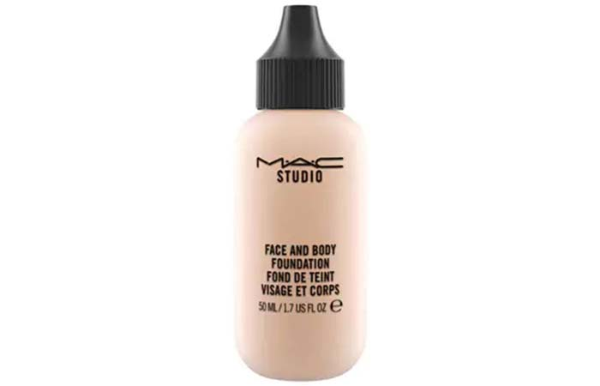](http://www.stylecraze.com/articles/best-mac-foundations/)

[**Save**](https://www.pinterest.com/pin/create/button/?guid=hvQeKU2xMzfb-12&url=http%3A%2F%2Fwww.stylecraze.com%2Farticles%2Fbest-mac-foundations%2F&media=http%3A%2F%2Fwww.stylecraze.com%2Fwp-content%2Fuploads%2F2014%2F05%2F9.-MAC-Face-and-Body-Foundation.jpg&description=11%20Best%20MAC%20Foundations%20For%20Different%20Skin%20Types)

The Face and Body Foundation by MAC is a lightweight foundation, and it delivers sheer coverage with a satin finish. It’s a moisturizing, long-wearing formula and it glides onto your face and body providing stay-true color. 13 different shades available.

***Pros***

* Long-wearing, up to a good 8-9 hours
* Hydrating and non-drying
* Water resistant
* Good for sensitive skin
* Non-acnegenic

***Cons***

* Does not work on stubborn pigmentation issues
* Not suitable for extremely oily skin

**MAC Face and Body Foundation Review**

If you’re looking for something super natural and lightweight, then this foundation is the right choice. I love how easy it is to work with this foundation and the way it just blends in perfectly. It gives your skin a luminous glow, evening out your skin tone and smoothening minor imperfections. It’s a great product for daily wear. It does not accentuate pores, streaks or gets cakey; rather, it stays on perfectly all day long!

**Rating:**4.3/5

**Price:**$38* for 120 ml

**Where to Buy MAC Face and Body Foundation Online?**

**Purchase Link:**[amazon.com](https://www.amazon.com/MAC-Face-Body-Foundation-N3/dp/B004SD19LY/ref=sr_1_1_a_it)

[**Back To TOC**](http://www.stylecraze.com/articles/best-mac-foundations/#BackToToc)

**10. MAC Matchmaster SPF 15 Foundation**

[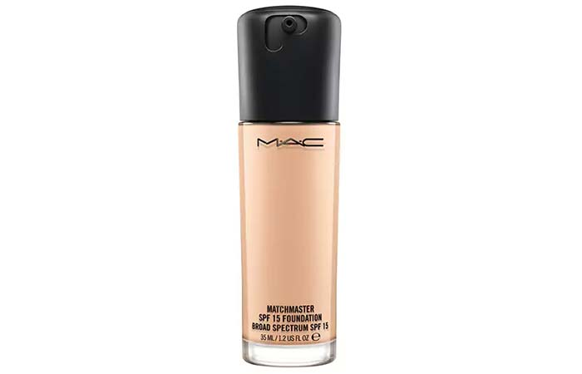](http://www.stylecraze.com/articles/best-mac-foundations/)

[**Save**](https://www.pinterest.com/pin/create/button/?guid=hvQeKU2xMzfb-13&url=http%3A%2F%2Fwww.stylecraze.com%2Farticles%2Fbest-mac-foundations%2F&media=http%3A%2F%2Fwww.stylecraze.com%2Fwp-content%2Fuploads%2F2014%2F05%2F10.-MAC-Matchmaster-SPF-15-Foundation.jpg&description=11%20Best%20MAC%20Foundations%20For%20Different%20Skin%20Types)

This formula contains customizable pigments that adjust to your skin tone in a flawless matte finish with medium buildable coverage. It helps reduce shine on the face and absorbs excess oil. It also provides perfect color purity without looking chalky or ashy. Comes with SPF 15 and broad spectrum protection. It comes in 12 different shades.

***Pros***

* Long-wearing, lasts 8-9 hours
* Oil-free and controls oil
* Suitable for all skin types
* Non-acnegenic
* Offers broad spectrum protection
* Buildable coverage

***Cons***

* It’s a little heavy for daytime
* Dries out soon so you have to be quick

**MAC Matchmaster SPF 15 Foundation Review**

The Matchmaster indeed adapts to your skin and evens it out. It can be worn in any weather condition. It’s lightweight and easy to blend. The coverage is medium to buildable, and the texture is just the right amount of creamy. It does not settle into fine lines rather it blurs them out and helps minimize their appearance. Overall, this is a great foundation with SPF 15 if you are looking for something long-lasting.

**Rating:**4.2/5

**Price:**$38*

**Where to Buy MAC Matchmaster SPF 15 Foundation Online?**

**Purchase Link:**[amazon.com](https://www.amazon.com/M-C-Matchmaster-Foundation-1-5/dp/B00I6E9QE8/ref=sr_1_2_s_it)

[**Back To TOC**](http://www.stylecraze.com/articles/best-mac-foundations/#BackToToc)

**11. MAC Mineralize Foundation/Loose**

[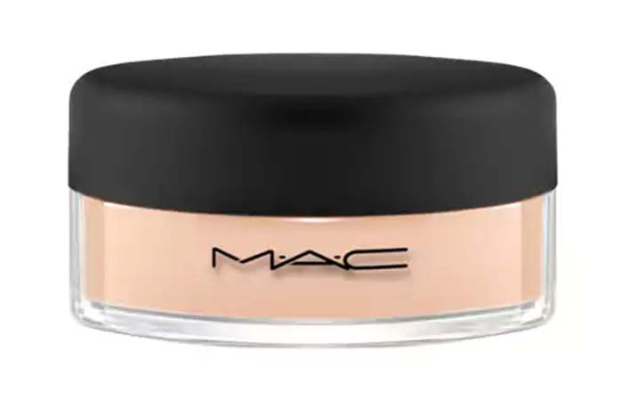](http://www.stylecraze.com/articles/best-mac-foundations/)

[**Save**](https://www.pinterest.com/pin/create/button/?guid=hvQeKU2xMzfb-14&url=http%3A%2F%2Fwww.stylecraze.com%2Farticles%2Fbest-mac-foundations%2F&media=http%3A%2F%2Fwww.stylecraze.com%2Fwp-content%2Fuploads%2F2014%2F05%2F11.-MAC-Mineralize-FoundationLoose.jpg&description=11%20Best%20MAC%20Foundations%20For%20Different%20Skin%20Types)

This is a silky, mineral-rich powder foundation that brushes on to deliver medium buildable coverage and a natural look. It helps your skin achieve a smooth, dimensional finish with exceptional luminosity and a velvet-soft finish. This is available in 9 shades.

***Pros***

* A comfortable, lightweight formula
* Great for sensitive skin
* Talc and fragrance-free
* Non-drying
* Provides a lasting wear

***Cons***

* Does not do a great job at coverage

**MAC Mineralize Foundation/Loose Review**

The thing about this foundation is that it is perfect for people with already flawless skin. So if you have blemishes or dark spots, this won’t satisfy your needs. It’s a very sheer coverage product that primarily adds a luminous glow to the skin. It helps control oil. You can use this with a makeup sponge or a brush, and it blends in quite easily. If you don’t want to put on a full face of creamy foundation and want to keep it real basic – get yourselves one of these. But if you are someone who stresses upon coverage – this is not meant for you.

**Rating:**4/5

**Price:**$35*

**Where to Buy MAC Mineralize Foundation/Loose Online?**

**Purchase Link:**[amazon.com](https://www.amazon.com/MAC-Mineralize-Foundation-Loose-MEDIUM/dp/B007XB1CHE/ref=sr_1_2_s_it?s=beauty&ie=UTF8&qid=1504076561&sr=1-2&keywords=MAC+Mineralize+Foundation%2FLoose)

[**Back To TOC**](http://www.stylecraze.com/articles/best-mac-foundations/#BackToToc)

**Expert’s Answers For Readers’ Questions**

**What are the best mac liquid foundations?**

The MAC Studio Fix Fluid Foundation, Studio Face and Body Foundation and the Pro Longwear Foundation are a few of the best liquid foundations out there. They stay on for long durations without wearing out or giving you a cakey effect. They are also available in a wide range of shades to choose from.

**What are the best MAC powder foundations?**

MAC Studio Fix Powder Plus Foundation and Mineralize Foundation/Loose are two of the best powder based foundations. They are lightweight and comfortable to wear on a daily basis. If you want to avoid a full face of liquid makeup, these are great options to choose from.

**Best MAC foundation for wedding?**

MAC Pro Long Wear Foundation and MAC Face and Body Foundation are best for events such as weddings mainly because they are high coverage, they stay put for over 15 hours and they are also very photo-friendly. They give you the most flawless base to look your best on your big day.

**Best high coverage MAC foundations?**

MAC Pro Long Wear Foundation, Studio Fix Fluid Foundation and MAC Face and Body Foundation give you a medium to full coverage. It’s buildable so you can achieve the highest coverage with these three. They even out your skin tone, hide all imperfections and stay on for long hours.

**Best MAC foundation for photography?**

MAC Studio Fix Fluid Foundation and Studio Sculpt are very photo-friendly when compared to the others. It actually depends on factors like using the exact shade for your skin, its application and how it sets in.

**Best matte MAC foundation?**

MAC Studio Fix Powder Plus Foundation gives you the most mattifying effect. The powder based foundation controls excessive oil and also absorbs it giving you a shine-free, matte effect.

**Recommended Articles**

* [**15 Best Drugstore Foundations For Different Skin Types**](http://www.stylecraze.com/articles/best-drugstore-foundations/?ref=end)
* [**How To Apply Cream Foundation? – Step by Step Tutorial**](http://www.stylecraze.com/articles/how-to-apply-cream-foundation/?ref=end)
* [**10 Best Water Based Foundations in India**](http://www.stylecraze.com/articles/water-based-foundations-available-in-india/?ref=end)
* [**10 Best Powder Foundations in India**](http://www.stylecraze.com/articles/best-powder-foundations-available-in-india/?ref=end)